**Java Exception classes Hierarchy**

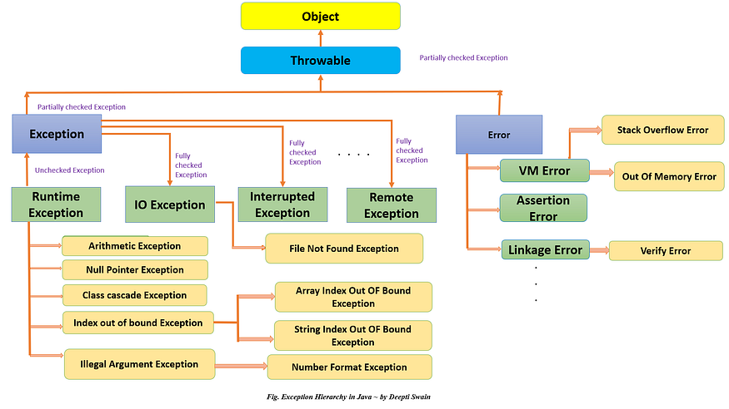

**Selenium Exception classes Hierarchy:--**

